Module ICT3715

INFORMATION AND COMMUNICATION TECHNOLOGY PROJECT

|  |  |  |  |  |  |  |  |  |  |
| --- | --- | --- | --- | --- | --- | --- | --- | --- | --- |
| STUDENT NUMBER (Student completes) | | | | | | | | | |
| 5 | 1 | 1 | 5 |  | 2 | 1 | 7 |  | 7 |

|  |  |  |  |  |  |  |  |  |  |  |  |  |
| --- | --- | --- | --- | --- | --- | --- | --- | --- | --- | --- | --- | --- |
| IDENTITY NUMBER (Student completes) | | | | | | | | | | | | |
| 7 | 9 | 0 | 9 | 2 | 3 | 5 | 5 | 3 | 5 | 0 | 8 | 0 |

No handwritten assignments will be accepted.

**INSTRUCTIONS:**

Complete this Front Page (page 1)

Complete the Plagiarism Pledge (page 2)

Complete the header and footer with your own information

Add your practical system content to the document

Remove everything that is in brackets []

Make sure that your Table of Content is updated

Save the document as a MS Word Document, e.g., 12345678_ICT3715_Portfolio (replace 1234568 with your student number)

When you are done submit via myModules 2022 on the Module Site under Project Portfolio Document

Keep a copy of the original should there be problem with the upload

PLAGIARISM PLEDGE BY THE STUDENT

1. I have read Unisa’s plagiarism policy.
2. I understand Unisa’s plagiarism policy.
3. I agree to abide by Unisa’s plagiarism policy.
4. I have read the direct copying, plagiarism, and “patch-writing” document.
5. I understand what direct copying, plagiarism, and “patch-writing” is.
6. I undertake to avoid copying directly, plagiarism and patch writing.
7. All academic work, written or otherwise, that I submit is expected to be the result of my own skill and labour.
8. I understand that, if I am guilty of the infringement of breach of copyright/plagiarism or unethical practice, I will be subject to the applicable disciplinary code as determined by Unisa.
9. The marker has the right to refuse to assess the assignment and the system if plagiarism is detected.

Student name and Surname: _Tshililo Theophelus Makhado____________

Student number: _________51152177_____________

___TTM______ __10/02/2023___

Student signature: Date:

**System | Online examination file submission system**

Due to the pandemic, the University of South Africa (UNISA) has decided to **conduct all examinations in an online environment.**

The **purpose of this project** is then to look at the digital environment and **design and develop a simulation of such a system, using the real-life scenario and environment.**

You thus must design and develop an online examination file submission system, that can be presented to the University to be used as an alternative to the current system.

**Note**: You are not allowed to develop any other system or use any other data that was not prescribed or provided to you.

Table of Contents

User Guide (Manual) 7

Testing & Implementation Plan | Installation Manual 8

Business Plan 8

Assignment 3 10

Section A = MIS Reports [20] 10

Create the Daily MIS report (5) 11

Create the Weekly MIS report (5) 12

Create one other MIS report (5) 13

Create one other MIS report (5) 14

Section B = Graphical User Interfaces [20] 15

Student login GUI (7) 15

Lecturer login GUI (7) 16

Exam Department (Staff member) login GUI (6) 17

Assignment 2 18

Section A = Database [20] 18

Create the database for your system and importing the data from your .csv file (20) 18

Section B = Backup and Recovery for the Database and Programming code [10] 24

Database (5) 24

Programming code & Portfolio (assignments) (20) 25

Assignment 1 31

Section A [4] 31

Programming Languages (2) 31

Database (2) 31

Section B [10] 31

Cleaning the data 31

Section C [10] 34

Activity Diagram (7) 34

ERD Diagram (3) 35

Section Backup and Recovery for the Database and Programming code [6] 35

Backup and Recovery Software for the Database (3) 35

Backup and Recovery process for the Programming code and your Portfolio (assignments) (3) 37

# User Guide (Manual)

Please click on the attached word document for the user guide.



# Testing & Implementation Plan | Installation Manual

Please click on the attached word document for the installation Manual.



# Business Plan

Please click on the attached word document for the business Plan.



# Test Data

student login: 11357287@mylife.unisa.ac.za, 12345

lecturer staff login: d.zulu@unisa.ac.za, 1111

exam department staff login: [tshepomale@unisa.ac.za](mailto:tshepomale@unisa.ac.za), tshepomaleka1

# Other Details

000Webhost details

username: theo.makhado@gmail.com

password: Ndouvhada1?

URL: https:///51152177-ict3715.000webhostapp.com

DB Name id20293301_ict3715_2022

DB User id20293301_theomakhado

DB Host localhost

DB Password bVzczJTKINBU&Hd^nL4y

Google Drive

<https://protect-za.mimecast.com/s/Ub5MCqj5YNsLx40ZxSQXUQO?domain=drive.google.com>

GITHUB

username: [theo.makhado@gmail.com](mailto:theo.makhado@gmail.com)

password: Oneahomak1?

URL: <https://protect-za.mimecast.com/s/6HVpCpgKQMcQJlMmJTDexgv?domain=github.com>

# Assignment 3

## Section A = MIS Reports [20]





For purposes required by the Examination Department, the following MIS Reports must be presented in your systems dashboard:

**One Daily MIS report**

**One Weekly MIS reports**

**At least two more MIS reports**

|  |
| --- |
| For each of these MIS reports you have to do the following:   * In your own words, describe the reason for this MIS report. * Create the query (the SQL).   The query should be specific and the names of the tables that you use, columns, joints (PKs, FKs) etc. should be clear and precise.   * Run the query to get an output. * You need to provide the marker with each of these queries as well as screen dumps of the output (both the actual data and should you use graphics a screen dump of the graphic as well).   Again, remember, a report is NOT a looooong list of data. |

### Create the Daily MIS report (5)

Reason

To provide the Exam Department with a list of all modules with focus on the module code, module description and date of exam this information helps to identify when a particular module is being written.

Query

$stmt = $conn->prepare("SELECT examsetup.ModuleCode, ModDesc, DateExam

FROM examsetup, moduleinfo

WHERE examsetup.ModuleCode = moduleinfo.ModCode

ORDER BY ModuleCode");

$stmt->execute();

$modules = $stmt->fetchAll();

Screen dumps

### Create the Weekly MIS report (5)

Reason

Display all lecturer’s info for the exam department and links the modules that they are leading.

Query

$stmt = $conn->prepare("SELECT Distinct(moduleleader.ModuleCode), ModDesc, name, email, DateExam

FROM moduleleader, moduleinfo, staffinfo, examsetup

WHERE moduleleader.ModuleCode = moduleinfo.ModCode

AND examsetup.ModuleCode = moduleinfo.ModCode

AND moduleleader.StaffNumber = staffinfo.StaffNumber

ORDER BY ModuleCode");

$stmt->execute();

$modules = $stmt->fetchAll();

Screen dumps

### Create one other MIS report (5)

Reason

3D Bar graph of modules with most registered student

Query

const dataSource = {

chart: {

caption: "Modules with Most registered students",

subcaption: "(With Group Values)",

numbersuffix: " Students",

yaxisname: "No of registered (students)",

theme: "candy",

plottooltext: "No of $label in $seriesName is <b>$dataValue</b>"

},

FusionCharts.ready(function() {

var myChart = new FusionCharts({

type: "errorbar2d",

renderAt: "chart-container",

width: "100%",

height: '700',

dataFormat: "json",

dataSource

}).render();

});

Screen dumps

### Create one other MIS report (5)

Reason

Bar graph with top module submissions

Query

//STEP 3 - Chart Configurations

// Chart Configuration

"chart": {

"caption": "Top Module Submissions",

"xAxisName": "Module",

"yAxisName": "File Uploads",

"numberSuffix": "",

"theme": "candy",

},

// Chart Data

"data": chartData

}

};

FusionCharts.ready(function(){

var fusioncharts = new FusionCharts(chartConfig);

fusioncharts.render();

});

Screen dumps

## Section B = Graphical User Interfaces [20]

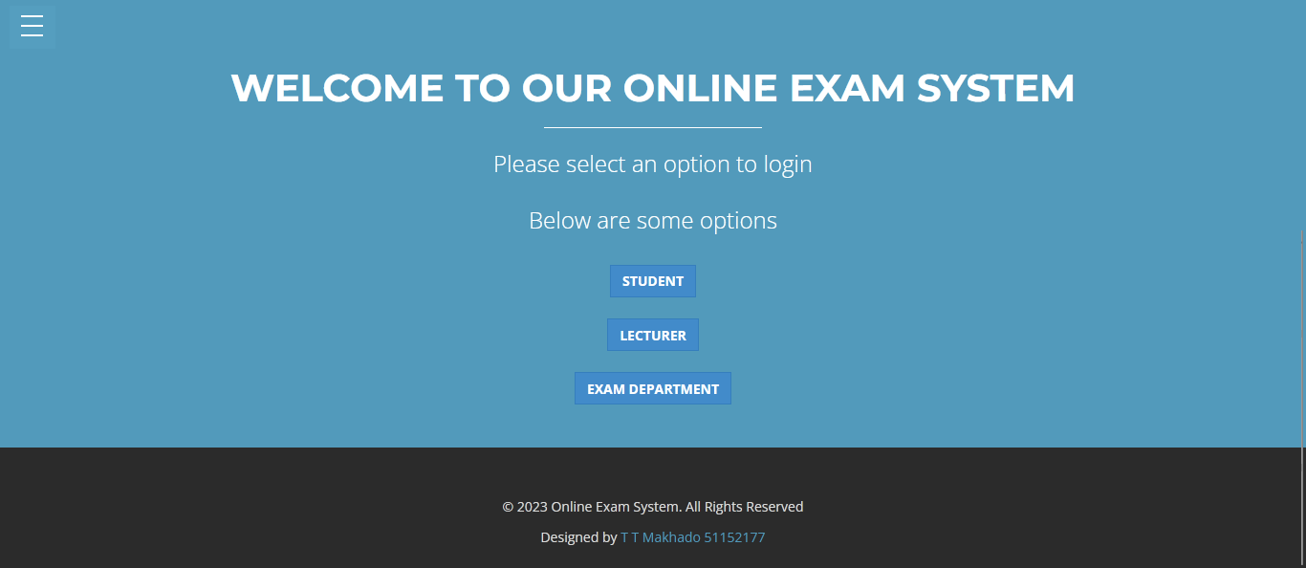

### Student login GUI (7)

**Creating the Graphical User Interfaces for the Student Login**

Screen dumps

Code

session_start();

require_once 'include/conn.php';

if(ISSET($_POST['submit'])){

if($_POST['username'] != "" || $_POST['password'] != ""){

$email = $_POST['username'];

$password = $_POST['password'];

$sql = "SELECT * FROM `studentinfo` WHERE `email`=? AND `password`=? ";

$query = $conn->prepare($sql);

$query->execute(array($email,$password));

$row = $query->rowCount();

$fetch = $query->fetch();

if($row > 0) {

$_SESSION['email'] = $fetch['email'];

$_SESSION['studentnumber'] = $fetch['studentnumber'];

$_SESSION['studentname'] = $fetch['studentname'];

header("location: stud");

} else{

echo "<script>alert('Invalid username or password')</script>";

}

}

}

### Lecturer login GUI (7)

**Creating the Graphical User Interfaces for the Lecturer Login**

Screen dumps

Code

session_start();

require_once 'include/conn.php';

if(ISSET($_POST['submit'])){

if($_POST['username'] != "" || $_POST['password'] != ""){

$email = $_POST['username'];

$password = $_POST['password'];

$sql = "SELECT * FROM `staffinfo` WHERE `email`=? AND `password`=? ";

$query = $conn->prepare($sql);

$query->execute(array($email,$password));

$row = $query->rowCount();

$fetch = $query->fetch();

if($row > 0) {

$_SESSION['staffnumber'] = $fetch['staffnumber'];

$_SESSION['name'] = $fetch['name'];

$_SESSION['email'] = $fetch['email'];

header("location: lect");

} else{

echo "<script>alert('Invalid username or password')</script>";

}

}

}

### Exam Department (Staff member) login GUI (6)

**Creating the Graphical User Interfaces for the Exam Department (Staff member) Login**

Screen dumps

Code

session_start();

require_once 'include/conn.php';

if(ISSET($_POST['submit'])){

if($_POST['username'] != "" || $_POST['password'] != ""){

$email = $_POST['username'];

$password = $_POST['password'];

$sql = "SELECT * FROM `examdeptstaff` WHERE `email`=? AND `password`=? ";

$query = $conn->prepare($sql);

$query->execute(array($email,$password));

$row = $query->rowCount();

$fetch = $query->fetch();

if($row > 0) {

$_SESSION['staffnum'] = $fetch['staffnum'];

$_SESSION['staffname'] = $fetch['staffname'];

$_SESSION['email'] = $fetch['email'];

header("location: exam_dept");

} else{

echo "<script>alert('Invalid username or password')</script>";

}

}

}

# Assignment 2

## Section A = Database [20]

### Create the database for your system and importing the data from your .csv file (20)

**Process**

* I started by opening the Data.csv file which was given to us
* I had to break down an analysis each table and columns needed per table
* I also analysed the data type and range for each of the columns and paid attention which are PK and FK
* I had to copy the columns needed per table on a separate worksheet which I then saved as separate csv file which represents each table
* Then using PHPMyAdmin I could easily create the database, tables and columns using the simple interface. The interface also allows to specify PK, FK and datatypes.
* Then I had to import the csv files to PHPMyAdmin to make sure the data was properly inserted.
* After this process then I extract an “SQL” file

**Problems**

The problems encountered where many I will break it down table by table and provide extra info

“studentmodule table”

* There was a lot of duplicate data of which I dealt with by deleting them in the csv file
* Making the 2 columns primary was simple as the interface provided that option
* Making the “ModuleCode” columns foreign key was hard, but I ran an SQL query to deal with that.
* ALTER TABLE `studentmodule` ADD PRIMARY KEY(`StudentNumber`, `ModuleCode`);

“studentinfo table”

* The only issue in this table was to create an email column and collect data from the studentnumber and add text. That issue was sort using the SQL query below
* UPDATE studentinfo SET email = StudentNumber + "@mylife.unisa.ac.za"

“staffinfo table”

* There was a lot of duplicate data of which I dealt with by deleting them in the csv file

“moduleleader table”

* There was a lot of duplicate data of which I dealt with by deleting them in the csv file
* Making the 2 columns primary was simple as the interface provided that option

“moduleinfo table”

* There was a lot of duplicate data of which I dealt with by deleting them in the csv file

“examsetup table”

* There was a lot of duplicate data of which I dealt with by deleting them in the csv file
* I also paid attention to the DATE datatype from the csv file

“examoutput table”

* There was a lot of duplicate data of which I dealt with by deleting them in the csv file
* I also paid attention to the DATE datatype from the csv file

Extra

* Just paying attention to certain datatypes such as date and time; I had to set them from the csv file so when it is imported it uses the right datatype.

**Screenshots**

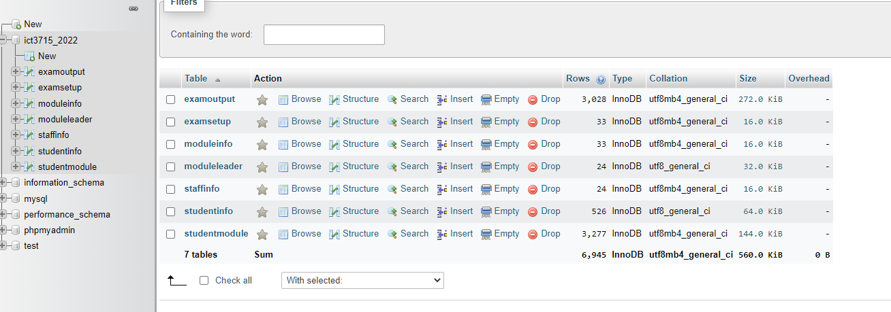

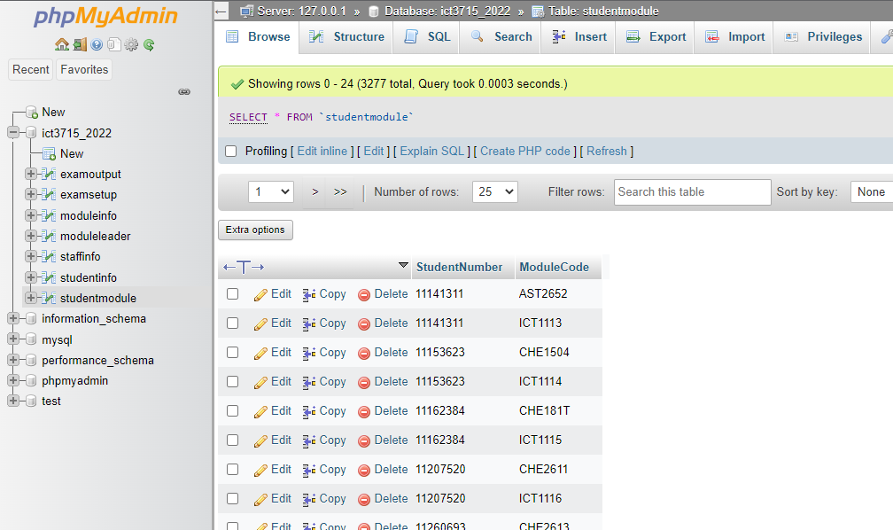

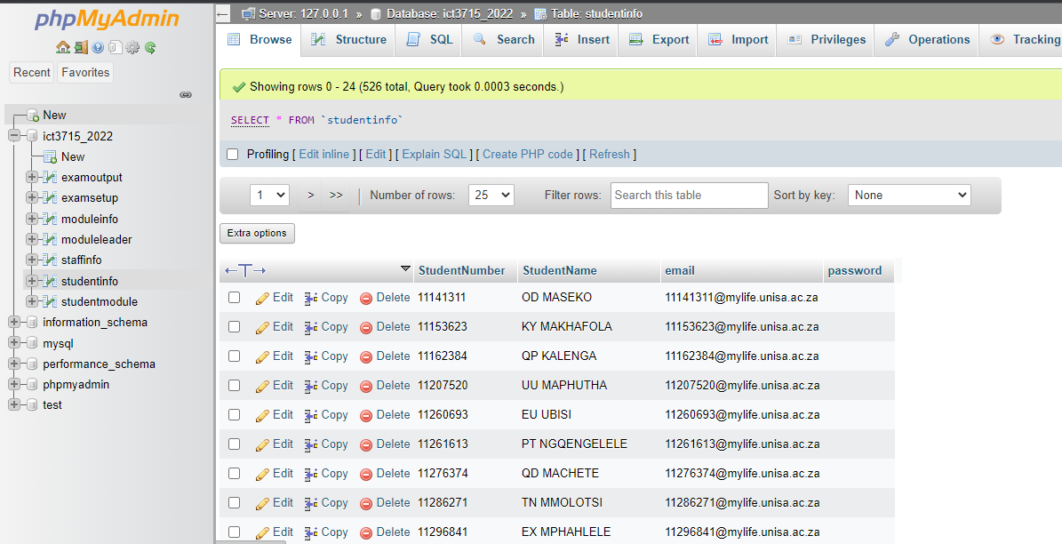

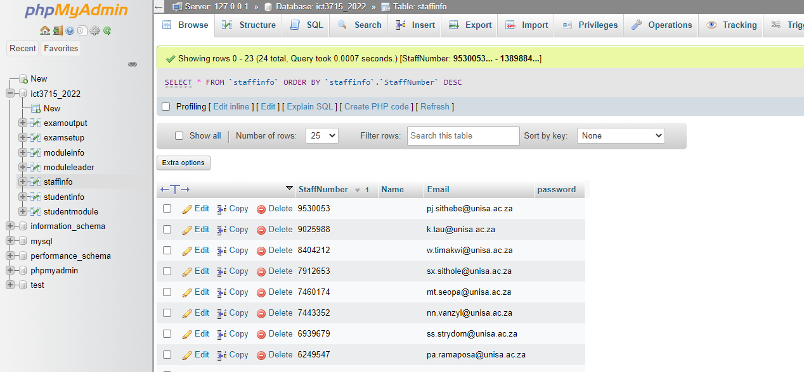

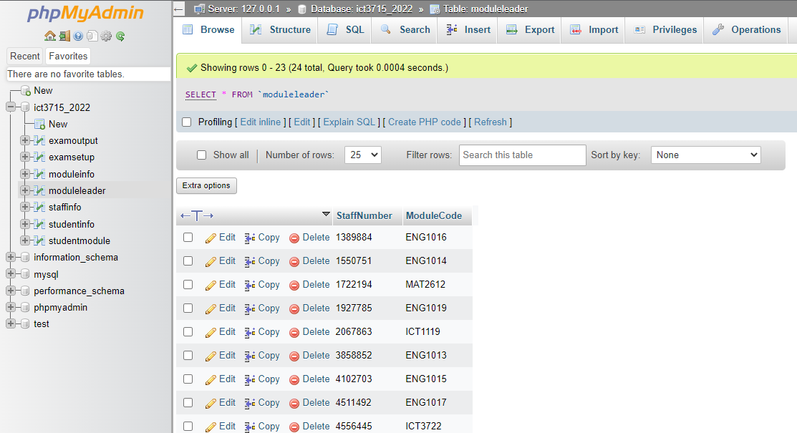

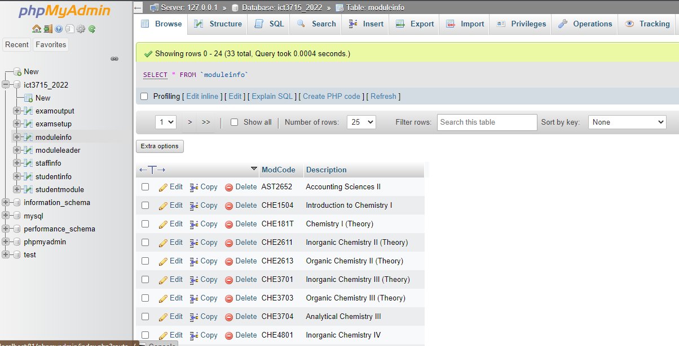

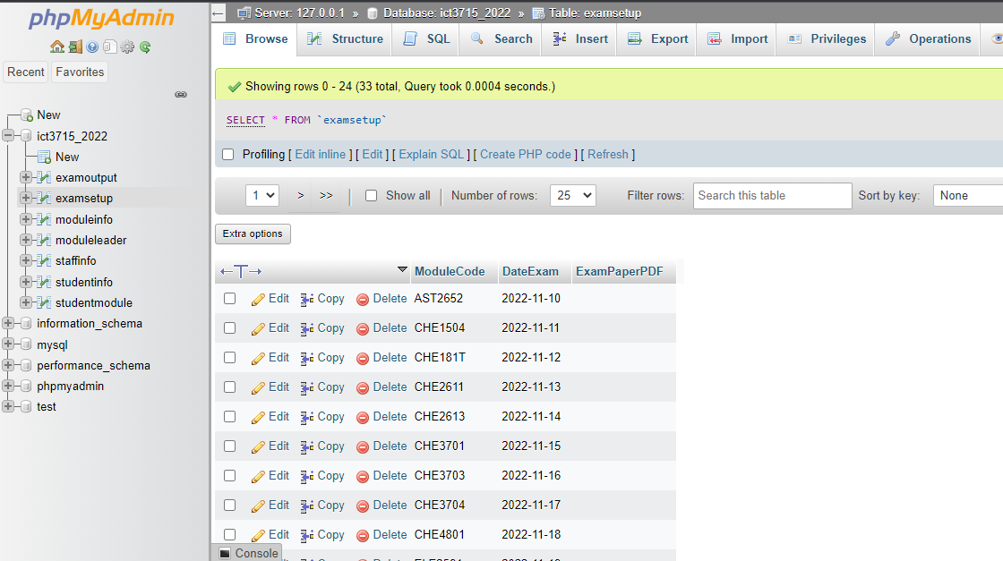

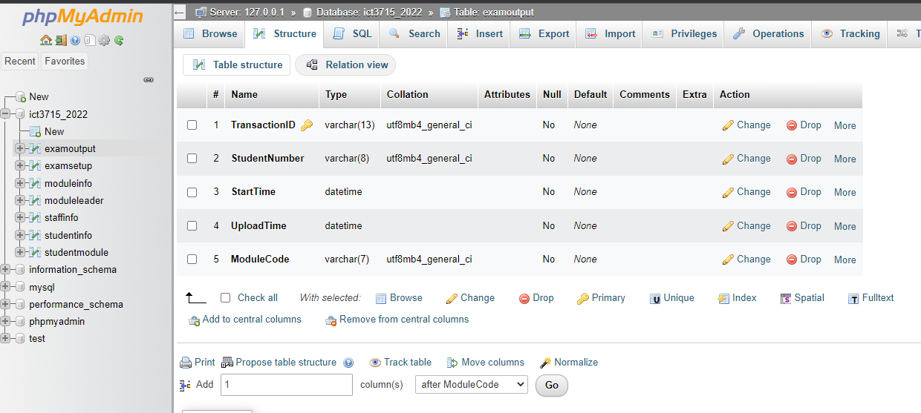

## Section B = Backup and Recovery for the Database and Programming code [10]

### Database (5)

1. I start by opening my xampp software and running PHPMyAdmin using the localhost
2. Then extract the sql and csv file from the database and it adds it to the downloads folder
3. Then this get uploaded on a weekly basis to my GitHub accounts as well as to Google Drive for extra backup
4. GitHub being a source control software I can commit changes and go back to previous changes. Basically, it allows me to track changes made to the database file
5. 000webhost will also be used to upload the database from the local server to a cloud-based server.
6. This is done weekly to keep track of changes and make sure I have no database crashes.

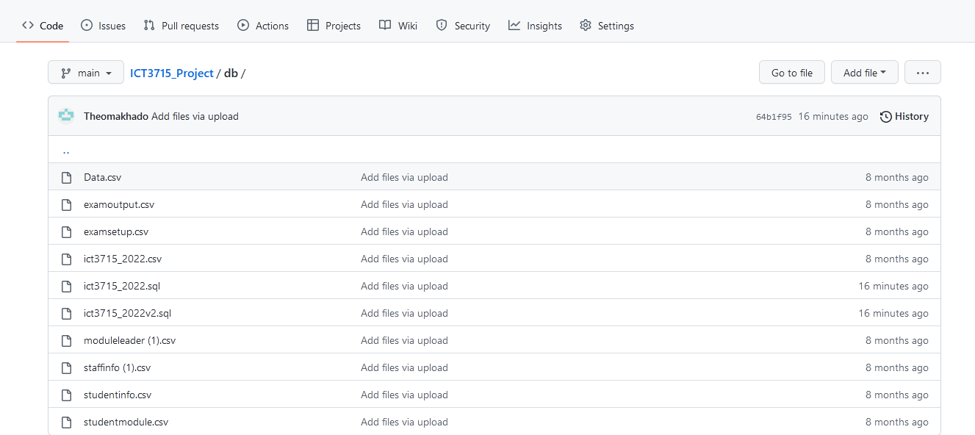

### Programming code & Portfolio (assignments) (20)

--

-- Database: `ict3715_2022`

--

-- --------------------------------------------------------

--

-- Table structure for table `examoutput`

--

CREATE TABLE `examoutput` (

`TransactionID` varchar(13) NOT NULL,

`StudentNumber` varchar(8) NOT NULL,

`StartTime` datetime NOT NULL,

`UploadTime` datetime NOT NULL,

`ModuleCode` varchar(7) NOT NULL

) ENGINE=InnoDB DEFAULT CHARSET=utf8mb4;

--

-- Table structure for table `examsetup`

--

CREATE TABLE `examsetup` (

`ModuleCode` varchar(7) NOT NULL,

`DateExam` date NOT NULL,

`ExamPaperPDF` varchar(150) NOT NULL

) ENGINE=InnoDB DEFAULT CHARSET=utf8mb4;

--

-- Table structure for table `moduleinfo`

--

CREATE TABLE `moduleinfo` (

`ModCode` varchar(7) NOT NULL,

`Description` varchar(100) NOT NULL

) ENGINE=InnoDB DEFAULT CHARSET=utf8mb4;

--

-- Table structure for table `moduleleader`

--

CREATE TABLE `moduleleader` (

`StaffNumber` varchar(7) NOT NULL,

`ModuleCode` varchar(7) NOT NULL

) ENGINE=InnoDB DEFAULT CHARSET=utf8;

--

-- Table structure for table `staffinfo`

--

CREATE TABLE `staffinfo` (

`StaffNumber` varchar(7) NOT NULL,

`Name` varchar(150) NOT NULL,

`Email` varchar(200) NOT NULL,

`password` text NOT NULL

) ENGINE=InnoDB DEFAULT CHARSET=utf8mb4;

CREATE TABLE `studentinfo` (

`StudentNumber` varchar(8) NOT NULL,

`StudentName` varchar(100) DEFAULT NULL,

`email` varchar(150) DEFAULT NULL,

`password` varchar(200) DEFAULT NULL

) ENGINE=InnoDB DEFAULT CHARSET=utf8;

--

**CREATE** **TABLE** `studentmodule` **(**

`StudentNumber` varchar**(**8**)** **NOT** **NULL,**

`ModuleCode` varchar**(**7**)** **NOT** **NULL**

**)** ENGINE**=**InnoDB **DEFAULT** CHARSET**=**utf8mb4**;**

--

--

-- Indexes for dumped tables

--

--

-- Indexes for table `examoutput`

--

ALTER TABLE `examoutput`

ADD PRIMARY KEY (`TransactionID`);

--

-- Indexes for table `examsetup`

--

ALTER TABLE `examsetup`

ADD PRIMARY KEY (`ModuleCode`);

--

-- Indexes for table `moduleinfo`

--

ALTER TABLE `moduleinfo`

ADD PRIMARY KEY (`ModCode`);

--

-- Indexes for table `moduleleader`

--

ALTER TABLE `moduleleader`

ADD PRIMARY KEY (`StaffNumber`,`ModuleCode`),

ADD UNIQUE KEY `ModuleCode` (`ModuleCode`);

--

-- Indexes for table `staffinfo`

--

ALTER TABLE `staffinfo`

ADD PRIMARY KEY (`StaffNumber`);

--

-- Indexes for table `studentinfo`

--

ALTER TABLE `studentinfo`

ADD PRIMARY KEY (`StudentNumber`);

--

-- Indexes for table `studentmodule`

--

ALTER TABLE `studentmodule`

ADD PRIMARY KEY (`StudentNumber`,`ModuleCode`);

COMMIT;



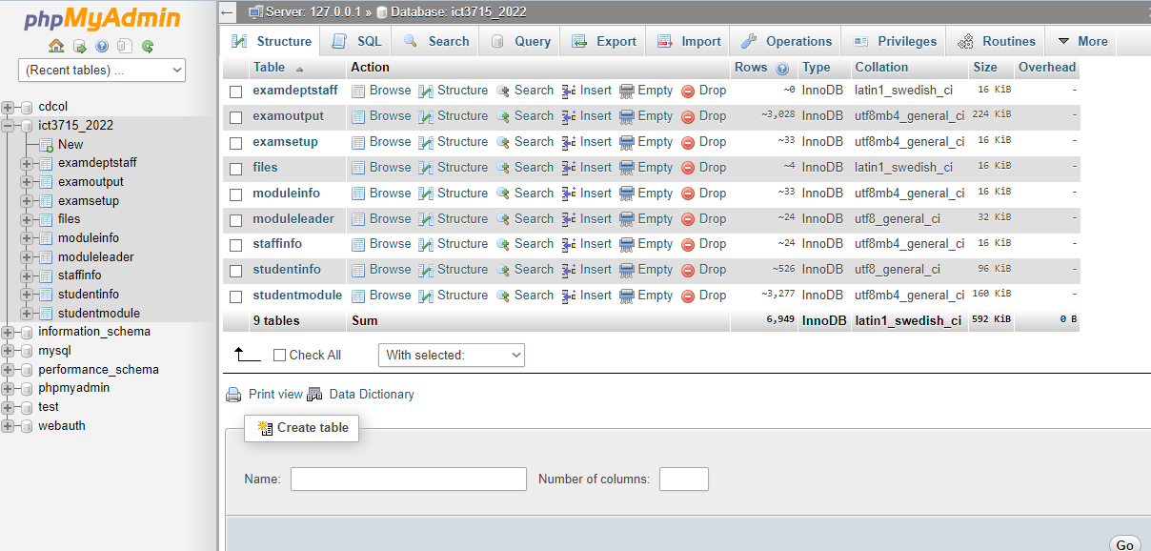

# Assignment 1

## Section A [4]

### Programming Languages (2)

PHP, JavaScript, jQuery, Bootstrap, Fusion Charts

### Database (2)

MySQL, PHPMyAdmin, MariaDB

## Section B [10]

### Cleaning the data

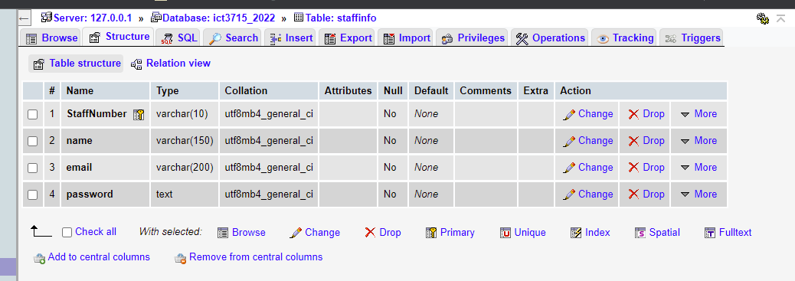

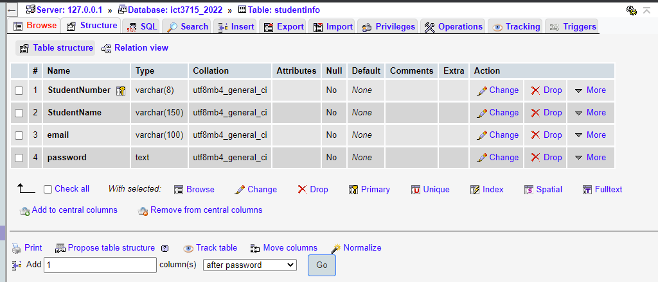

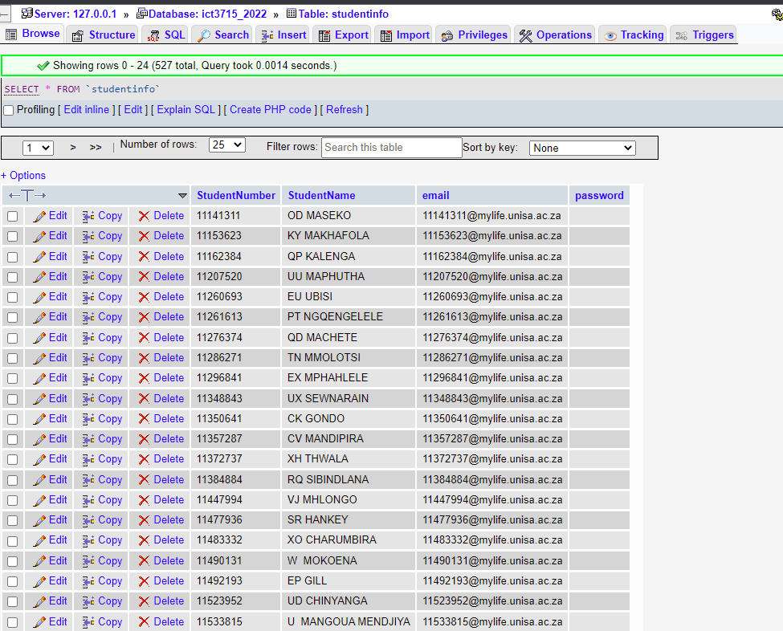

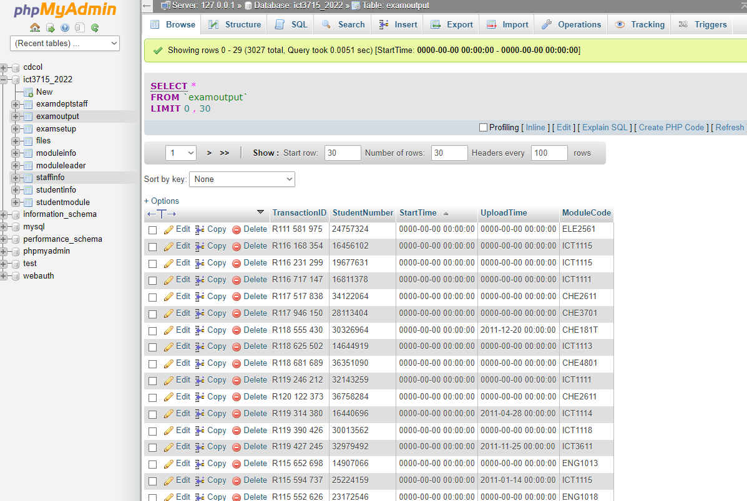

## Section C [10]

### Activity Diagram (7)

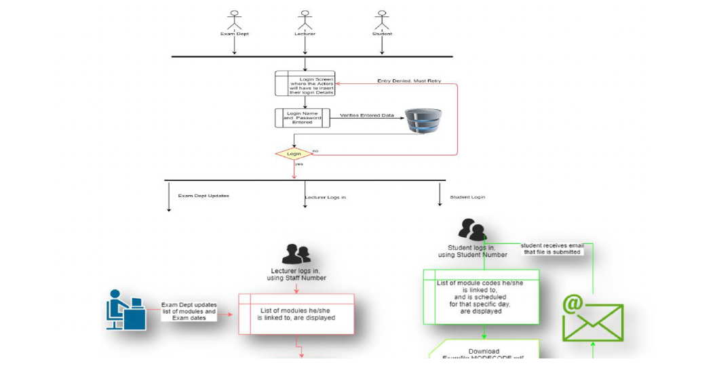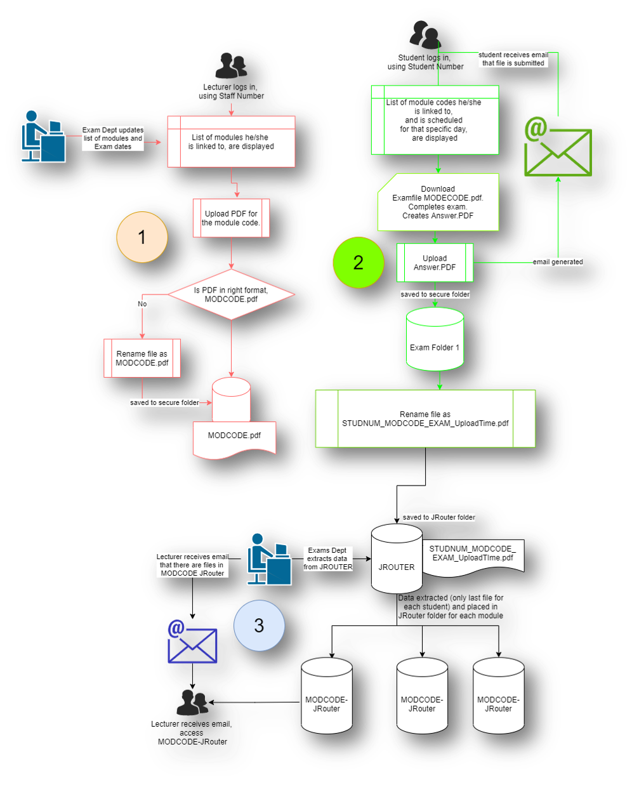

### ERD Diagram

## Section Backup and Recovery for the Database and Programming code [6]

### Backup and Recovery Software for the Database (3)

GitHub, 000Webhost, mySQLWorkBench, dbForge

GitHub – is a provider of Internet hosting for software development and version control using Git. It offers the distributed version control and source code management functionality of Git, plus its own features.



000Webhost - Free web hosting tends to be so limited in capabilities and features that users must pay to get what they need. However, 000webhost is a free website hosting solution that provides an array of valuable features, including a website builder, WordPress support, and no ads.

mySQLWorkBench - MySQL Workbench is a visual database design tool that integrates SQL development, administration, database design, creation, and maintenance into a single integrated development environment for the MySQL database system.

### Backup and Recovery process for the Programming code and your Portfolio (assignments) (3)

Google Drive, OneDrive, 000Webhost

Google Drive - is a file storage and synchronization service developed by Google. Google Drive allows users to store files in the cloud, synchronize files across devices, and share files.

Microsoft OneDrive is a file hosting service operated by Microsoft. It enables registered users to share and synchronize their files. OneDrive also works as the storage backend of the web version of Microsoft Office.

